SHARK TANK US SQL QUERIES

1. **KPI’s**
2. Total Number of Seasons

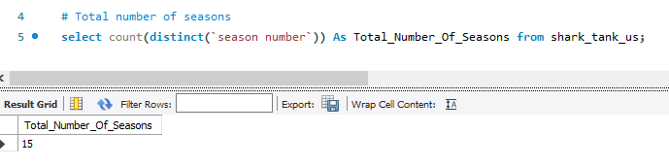

1. Total Number Of Pitches

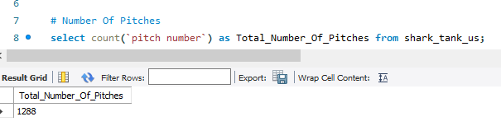

1. Number of Successful Deals

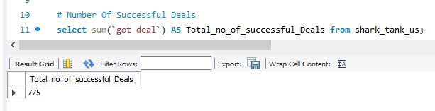

1. Count Of Industry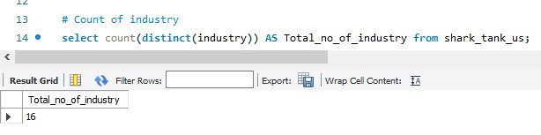
2. Total Deal Amount

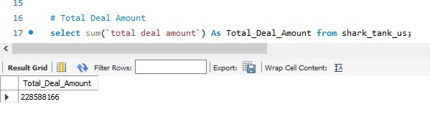

1. Total Shark equity count

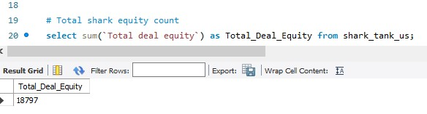

1. Total Valuation Requested

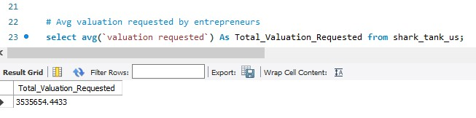

1. Find Top 10 industries name who received the highest investment

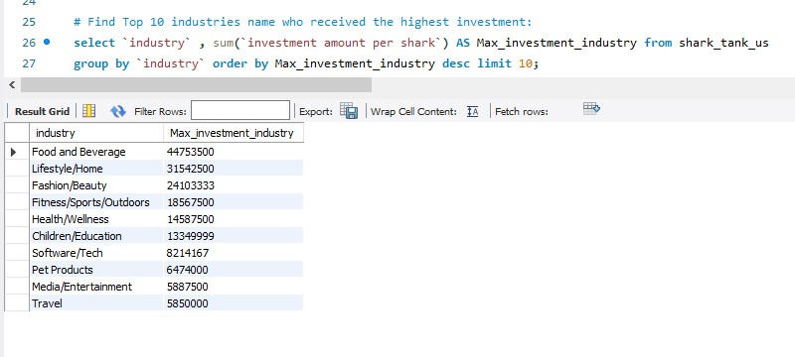

1. Retrieve Start up names who haven't received any deals

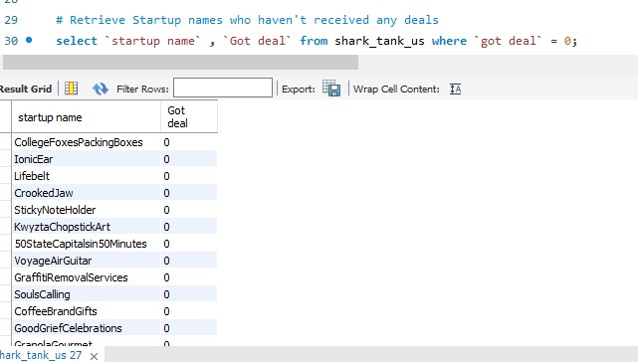

1. Guest investment amount by season number

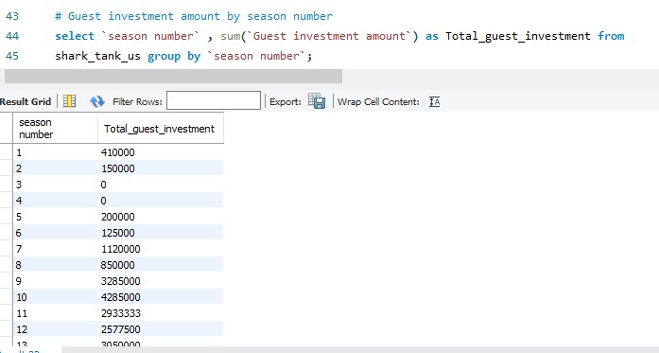

1. Seasonal pitch trend

